**CP Club 365 Days Challenge**

**Programming language – C++**

**Problem Statement**

<https://www.interviewbit.com/problems/best-time-to-buy-and-sell-stocks-i/>

Git :- <https://github.com/Vedantbharad2603/CP_club_365_Days>

**Your Code**:

// 0x126Day of 0x365Days challenge

// VEDANT BHARAD

// 18-2-2023

int Solution::maxProfit(const vector<int> &A) {

    if(A.size() == 0){

        return 0;

    }

    int toreturn = 0, temp = A[0];

    for(int i = 1; i < A.size(); i++){

        if(A[i] < temp){

            temp = A[i];

        }

        if(toreturn<A[i] - temp)

        {

            toreturn=A[i] - temp;

        }

    }

    return toreturn;

}

**Output (Screen Shot)**:

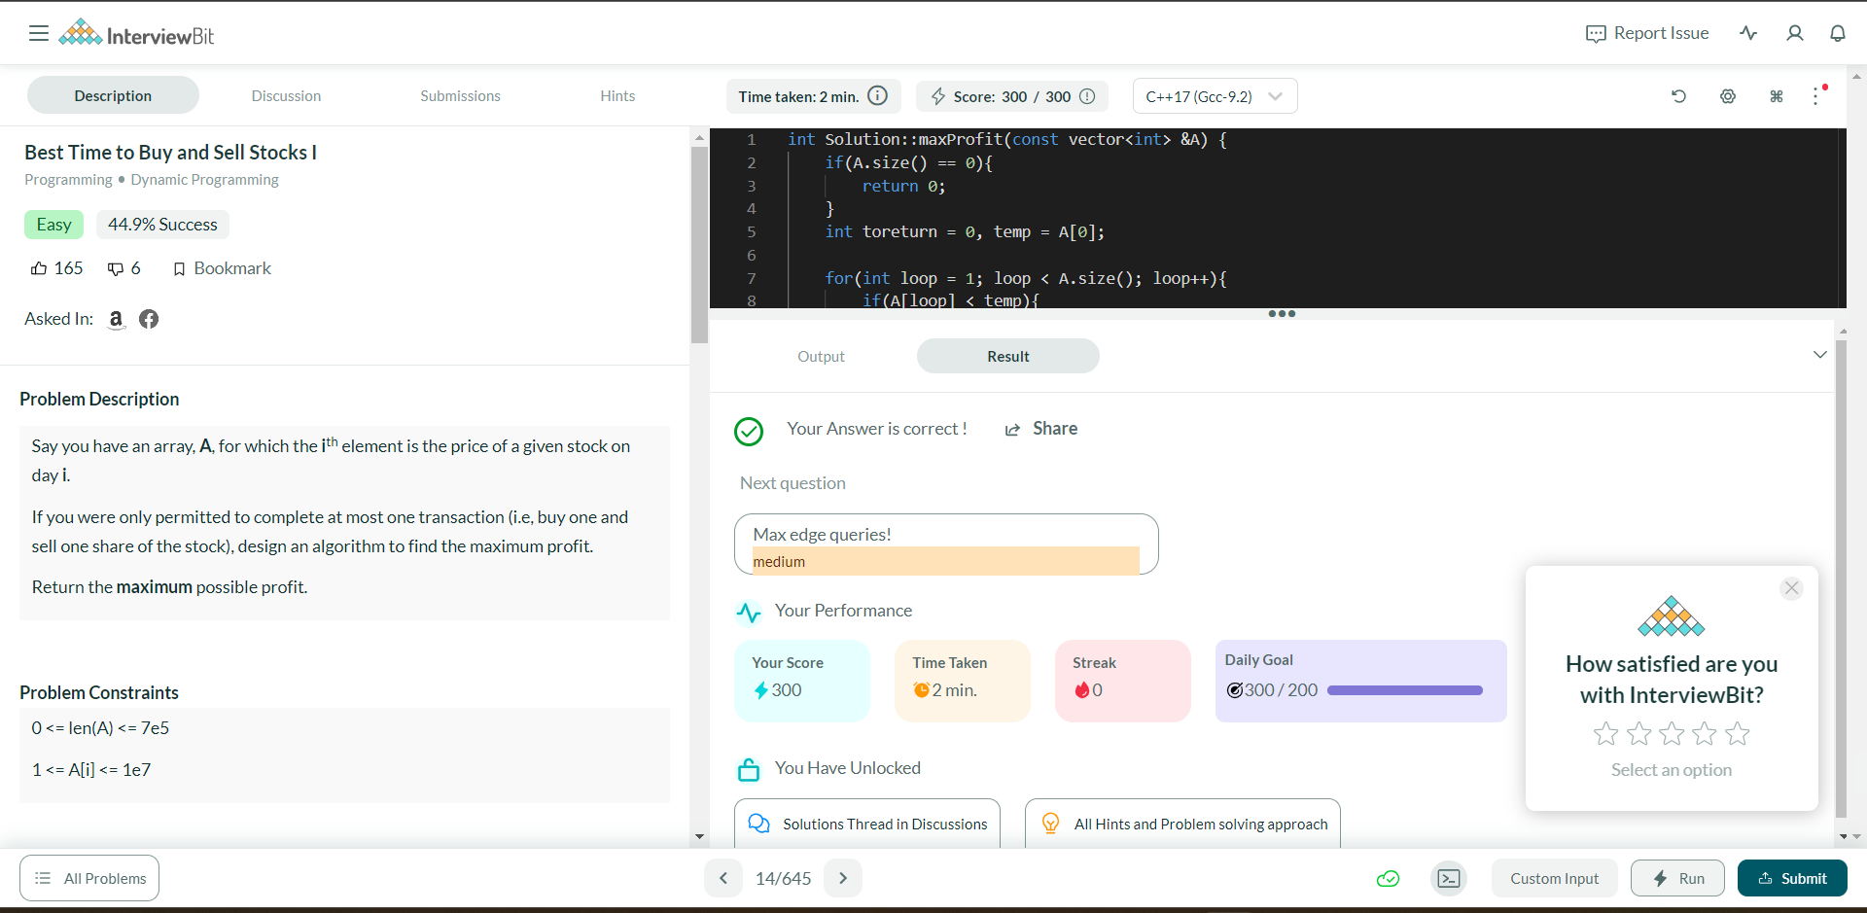

**Understanding about problem:**

* In this I need to return maximum possible profit from given array which is price of stock in n day.

Note: If you can't understand the problem, feel free to contact us and we'll help you. Please don't copy and paste from anywhere.

ALL THE BEST

Team CP Club